**Problem Set 2**

**Duration: 8 am – 4 pm**

This set is harder than set one. Here, you are asking to solve minimum five problems from [Project Eular](https://projecteuler.net/). Noted that all programs will be written using C Sharp language and application type will be console application. We always encourage google search for copying but for understanding, learning.

Happy rocking problem solving ☺

**Multiples of 3 and 5**

**Problem 1**

If we list all the natural numbers below 10 that are multiples of 3 or 5, we get 3, 5, 6 and 9. The sum of these multiples is 23.

Find the sum of all the multiples of 3 or 5 below 1000.

## Even Fibonacci numbers

### Problem 2

Each new term in the Fibonacci sequence is generated by adding the previous two terms. By starting with 1 and 2, the first 10 terms will be:

1, 2, 3, 5, 8, 13, 21, 34, 55, 89, ...

By considering the terms in the Fibonacci sequence whose values do not exceed four million, find the sum of the even-valued terms.

## Largest prime factor

### Problem 3

The prime factors of 13195 are 5, 7, 13 and 29.

What is the largest prime factor of the number 600851475143 ?

## Largest palindrome product

### Problem 4

A palindromic number reads the same both ways. The largest palindrome made from the product of two 2-digit numbers is 9009 = 91 × 99.

Find the largest palindrome made from the product of two 3-digit numbers.

## Smallest multiple

### Problem 5

2520 is the smallest number that can be divided by each of the numbers from 1 to 10 without any remainder.

What is the smallest positive number that is evenly divisible by all of the numbers from 1 to 20?

**Sum square difference**

**Problem 6**

The sum of the squares of the first ten natural numbers is,

12 + 22 + ... + 102 = 385

The square of the sum of the first ten natural numbers is,

(1 + 2 + ... + 10)2 = 552 = 3025

Hence the difference between the sum of the squares of the first ten natural numbers and the square of the sum is 3025 − 385 = 2640.

Find the difference between the sum of the squares of the first one hundred natural numbers and the square of the sum.

## 10001st prime

### Problem 7

By listing the first six prime numbers: 2, 3, 5, 7, 11, and 13, we can see that the 6th prime is 13.

What is the 10 001st prime number?

## Largest product in a series

### Problem 8

The four adjacent digits in the 1000-digit number that have the greatest product are 9 × 9 × 8 × 9 = 5832.

73167176531330624919225119674426574742355349194934  
96983520312774506326239578318016984801869478851843  
85861560789112949495459501737958331952853208805511  
12540698747158523863050715693290963295227443043557  
66896648950445244523161731856403098711121722383113  
62229893423380308135336276614282806444486645238749  
30358907296290491560440772390713810515859307960866  
70172427121883998797908792274921901699720888093776  
65727333001053367881220235421809751254540594752243  
52584907711670556013604839586446706324415722155397  
53697817977846174064955149290862569321978468622482  
83972241375657056057490261407972968652414535100474  
82166370484403199890008895243450658541227588666881  
16427171479924442928230863465674813919123162824586  
17866458359124566529476545682848912883142607690042  
24219022671055626321111109370544217506941658960408  
07198403850962455444362981230987879927244284909188  
84580156166097919133875499200524063689912560717606  
05886116467109405077541002256983155200055935729725  
71636269561882670428252483600823257530420752963450

Find the thirteen adjacent digits in the 1000-digit number that have the greatest product. What is the value of this product?

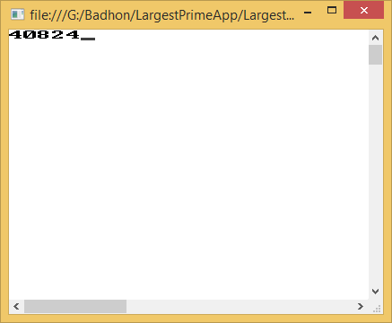

**Special Pythagorean triplet**

**Problem 9**

A Pythagorean triplet is a set of three natural numbers, *a* < *b* < *c*, for which,

*a*2 + *b*2 = *c*2

For example, 32 + 42 = 9 + 16 = 25 = 52.

There exists exactly one Pythagorean triplet for which *a* + *b* + *c* = 1000.  
Find the product *abc*.

## Summation of primes

### Problem 10

The sum of the primes below 10 is 2 + 3 + 5 + 7 = 17.

Find the sum of all the primes below two million.

